|  |  |
| --- | --- |
| **3/7** | **3/7** |
| 00:24:06 | 01:30:24 |
| V:2684 | V:1825 |

* Both CME’s were an hour apart.
* Occurred on the same day.
* About 900 km/s2 difference in velocity.
* 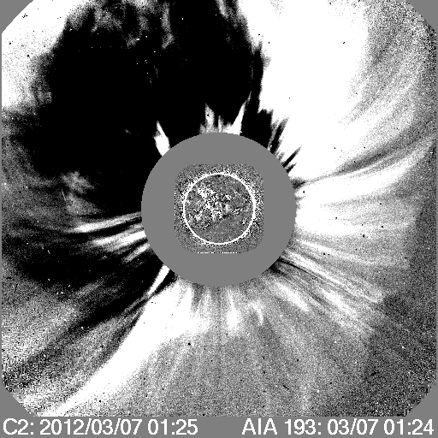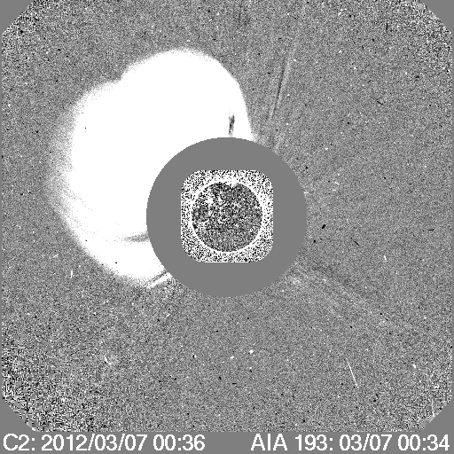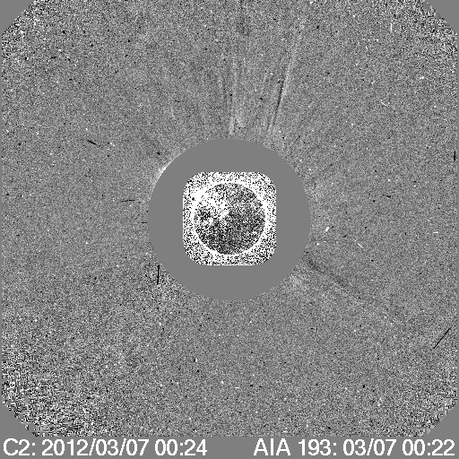First CME headed directly Northeast while second CME did the same but had more of an overall HALO effect.

Two CMEs of this mass and velocity would have a slim chance of being recorded by an IPS satellite that records data and images in 3 hours increments.

IPS and ENLIL only see one CME on their data. But why?

One reason for this could be that the first CME we see is direct and powerful to the Northeast. The second CME seen has more of a HALO effect in that it is spatially large. It takes up more space, the particles spread out more and are not as condensed into one area. Hence, the density for the second CME will be much smaller than the first CME where the particles are very compact. A CME with higher density is more likely to be seen and recorded into the tomography data.

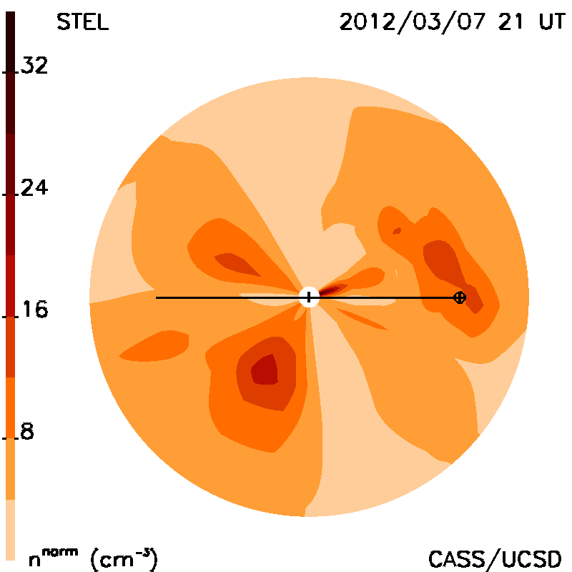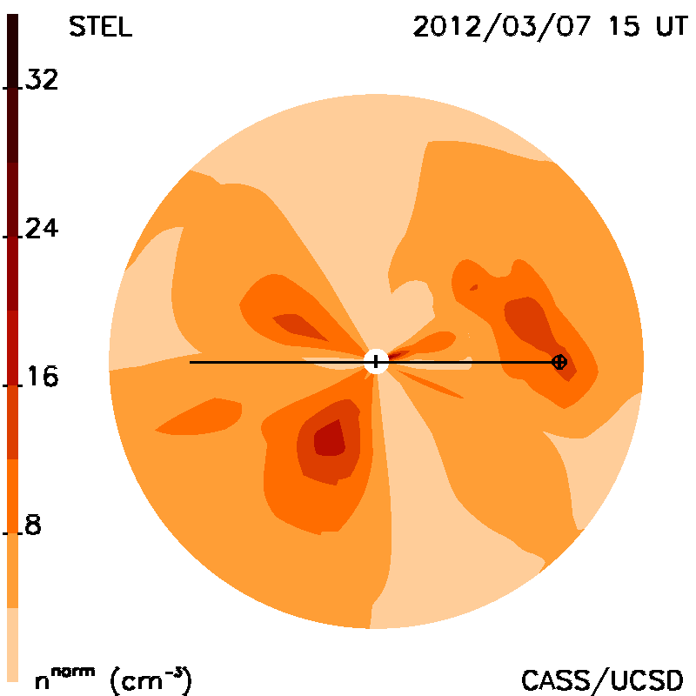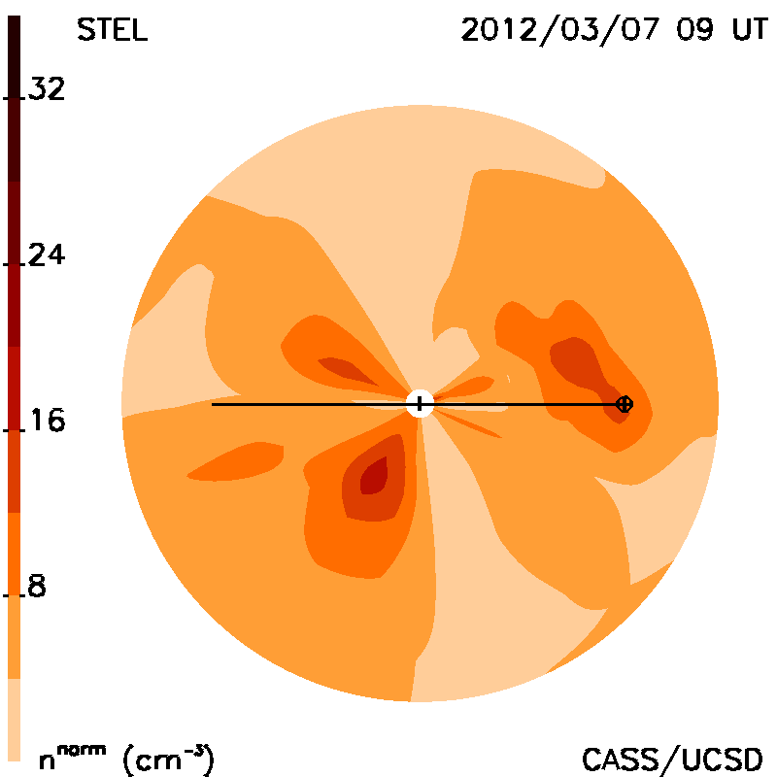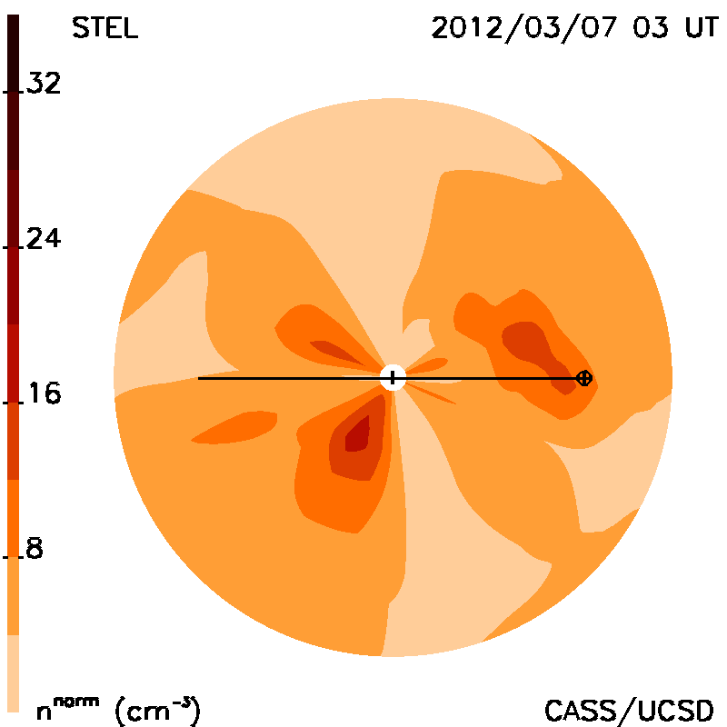Another reason could simply be the issue of the machine recording data in 3 hour increments. Both CMEs were at the times of 00 UT and 01 UT. These are extremely close and hard to separate CMEs when trying to create a picture. The satellite records at times 03 UT, 09 UT, 15 UT, and 21 UT. If these CMEs erupted before 03 UT, we would only see the very last part of the second CME, which is highly unlikely because of the density issue.

(Consider we put both of these CMEs together as one when talking about it. The machine would already mistake them for one CME either because of the density issue above or both of them being so close together in time and large in velocity even if they did occur during a favored time.)

Because we know the time of the flare which only takes a few minutes to get to earth by light speed, we can predict when the CME would start. But, light and mass are two very different things. Particles take longer to get to earth and take a much longer time to measure. So, when the satellite recorded the leftover particles from the CME’s that occurred in between the three hour time increments, it was much more difficult to figure out when the CME would arrive at Earth.

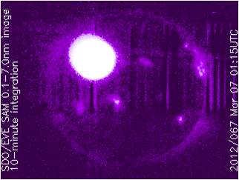Once IPS sees this last part of the CME, it will receive less particles, and less velocity. It will know the time of the first C2 appearance but figuring out exactly when the CME arrived at earth, the prediction will be off. The machine will have no idea exactly what the velocity was like in the beginning. Since it moved through so fast, there is barely anything left of the coronal mass ejections to analyze and the velocity of the particles will have slowed down by an immense amount. Therefore, the IPS data will believe that the CME was much slower than it really was, and predict it will arrive at Earth at a much later time than it really did.

*According to IPS data,*

First C2 appearance: 3/7 03 UT

CME first touches earth: 3/10 21 UT

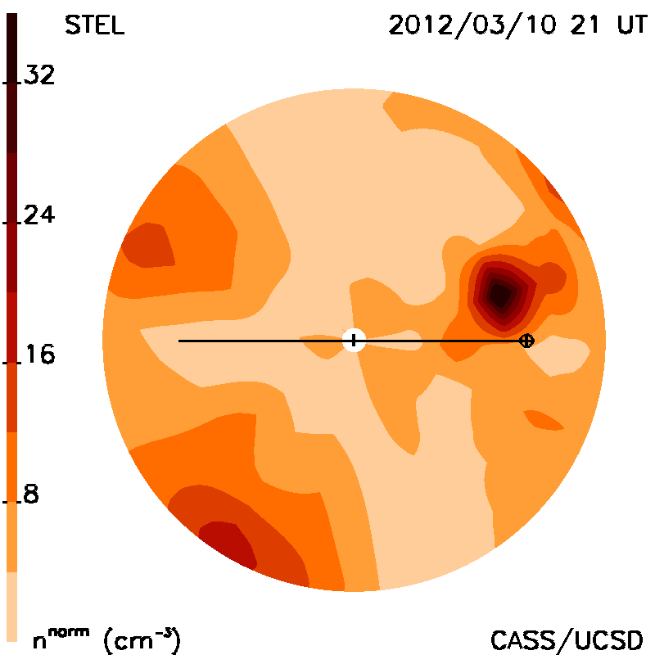 According to IPS Meridional cuts, the C2 appearance shows up at the correct time (for the CME that we can see). This is because we know the flare time. But, as said earlier, the velocity has slowed down immensely. Therefore the machine will believe the CME arrival time at earth is much later as well.

So, if we only see one CME on the images, then how do we know for sure there are two so close together? The IPS tomography data does not tell us. The images do not show it. Even when looking at the magnetic field changes, we cannot tell if there are one or two CMEs.

But, GOES X-Ray does. It is capable of receiving x-ray images and applying that data every 60 seconds. This gives early detection of the solar flares and coronal mass ejections. The GOES spacecraft carries a solar X-ray imager that monitors the sun’s x-rays. It can obtain images at multiple wavelengths on the electromagnetic spectrum thus telling us how strong and exactly when by the minute, these solar flares and CMEs occur.

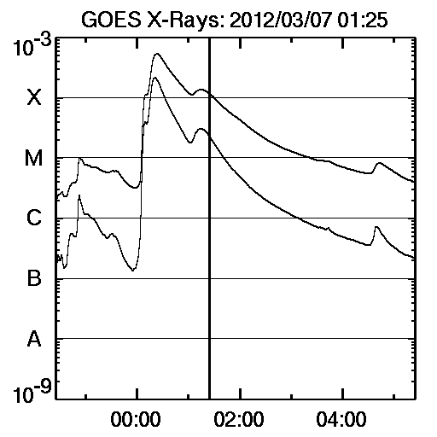The images below show two specific CMEs. The first one, which IPS detects on its images, is easily seen because of the drastic change in velocity, density, and escalates to class X. But, once the second one occurs, there is no drastic change in velocity and density because the timing is so close. Therefore it makes it harder for any space instrument to pick up a new burst in velocity or density. It would look like an aftershock or noise. But because GOES measures by light and not particles, it is capable of seeing this drastic difference and proving that there are two CMEs.

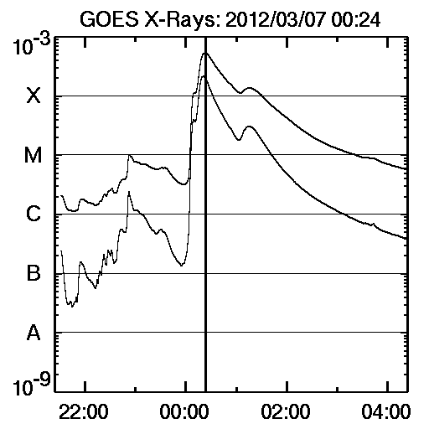

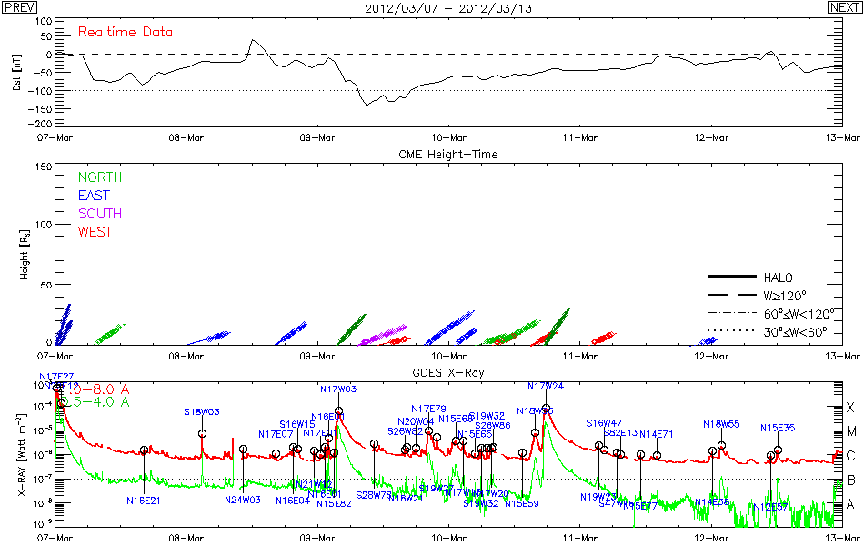 It is easily seen above and below that GOES x-ray has proven these CMEs to be of an X class flare.

Getting down to the point, X class flares will be stronger, faster, and harder to catch with technology that only records data at specific times.

IPS predicted the CME (which we could see in the images) would arrive at Earth at 3/10 21 UT. We know this is incorrect because if the first C2 appearance is at 3/7, it should not take that long, especially at over 2000 km/s2. So how do we find out?

Magnetic field data can tell us when there are fluctuations within the Earth’s magnetic field. A strong disturbance within the Earth’s magnetic field means that there is another magnetic field opposing it, the CME’s. In the figure below we can tell there is a drop in the magnetic field. This is where the CME dropped in. Therefore we have access to data on the specific date and time of this magnetic flux. Here it is seen around 3/9 9 UT.



This way, even if IPS data has trouble calculating the arrival date of the CME because of timing, there are other ways to find out. The downside to this; we would not find out until it hit Earth.

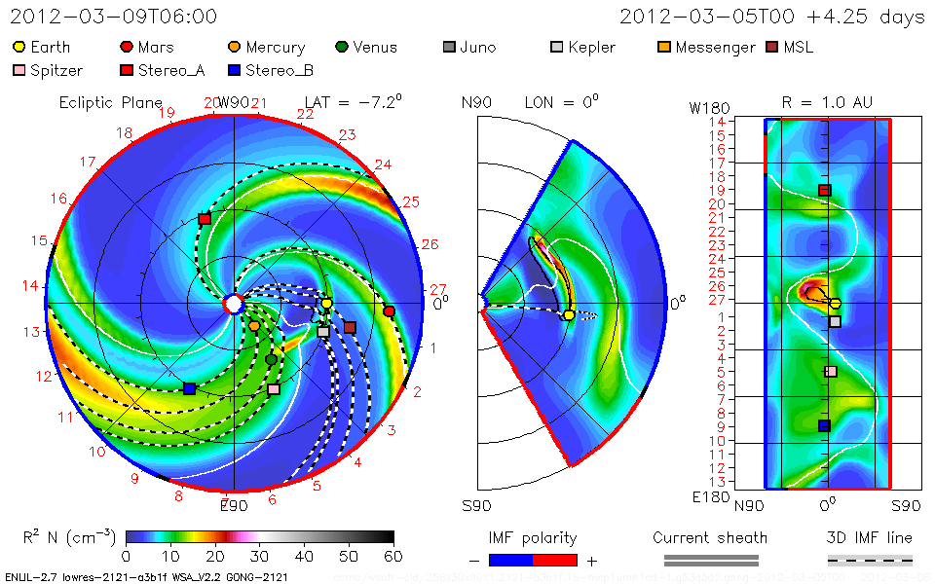Then again, if the GOES X-ray data had been used, then we would have known it was an X class flare, known it was stronger, faster, and could have predicted better.

ENLIL agrees with the change in the magnetic field once the CME touches earth. The white line shows the change in the magnetic field once they make contact.

ENLIL predicted the CME arrived at earth at 3/9 6 UT, 3 hours earlier. This is an extremely close comparison to the magnetic flux data above provided by “SOHO/LASCO NASA” data.

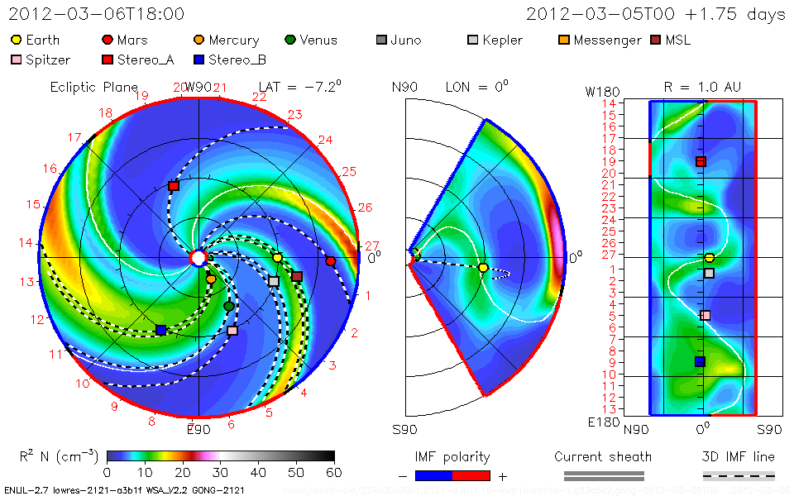 But, ENLIL did not agree on the first C2 appearance, predicting it had shown at 3/6 18 UT 6 hours too early.

While IPS was generally correct on the first C2 appearance, ENLIL made a better prediction on the CME’s arrival at Earth.

e3_2121.000_CELIAS_ips_D_delt_1.00.epse3_2121.000_WINDSWE_ips_D_delt_1.00.eps Referring to the graphs to the below, IPS says it did not see the 3/7 CME even though the IPS image did much later. Both the meridional picture and this graph measure in density. But, the imaging program is told to predict the density and fill in the areas when there is no data. So, the picture came up with the density it believed the CME had, even though it was late because of the lower velocity at the time recorded. The graph comparing IPS, WIND, and CELIAS data is extremely close to real time. These graphs do not fill in blank areas of data. If they didn’t see it, they didn’t see it.

If you look closely, there is no peak on the ninth or tenth. But, the previous peak for the dates of 4/5 and 4/6 is extremely thick and wide, ending on 3/10. Some of that thickness, could very well be the little data seen from the 3/7 CMEs. This little bit of data that was seen after the ejections on 3/7 3UT would be added to this peak, but not enough data strong enough to create its own peak.